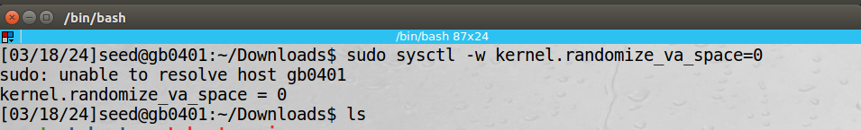

Task 1: vulnerable code:

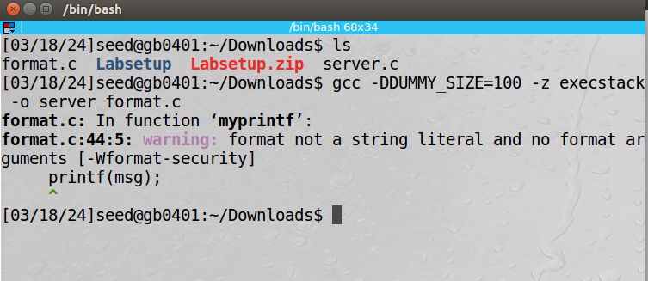

Task 2:

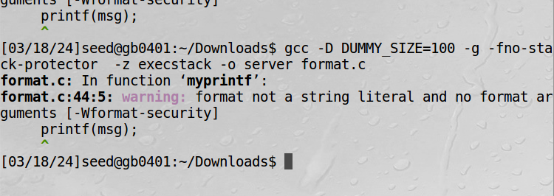

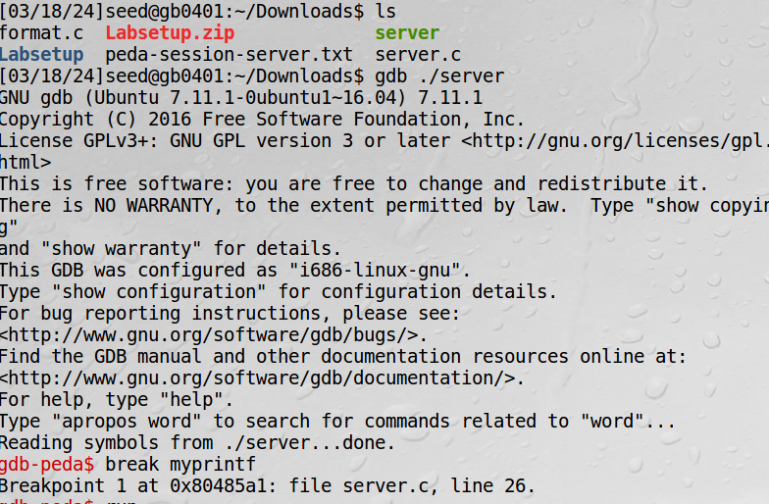

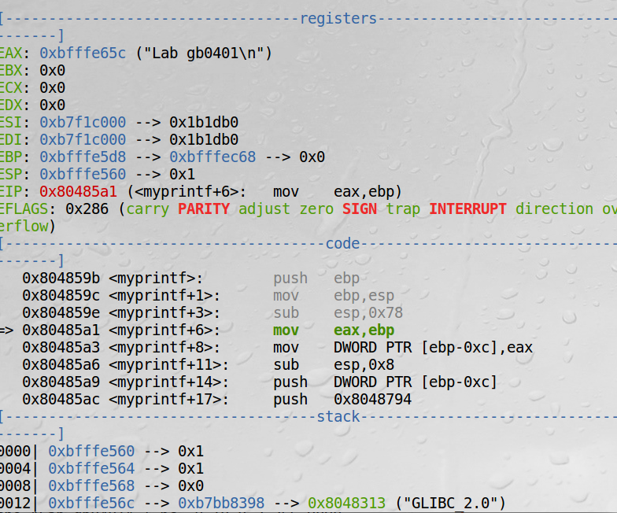

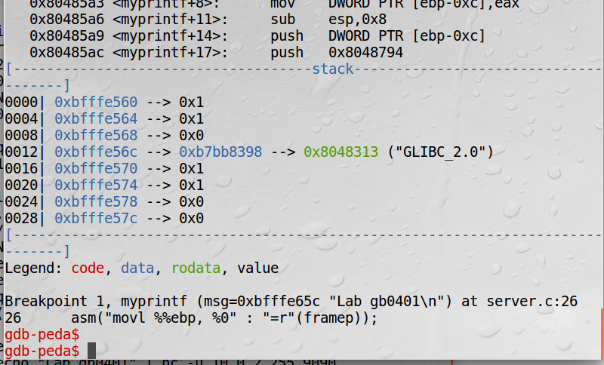

a)

Addresses are as follows:

* Format String in Printf(): 0xbfffe65c
* Return address of myprintf(): 0xbfffe5e0
* Buffer buff[1500] : 0xbfffe65c

b) 0

Task 3:

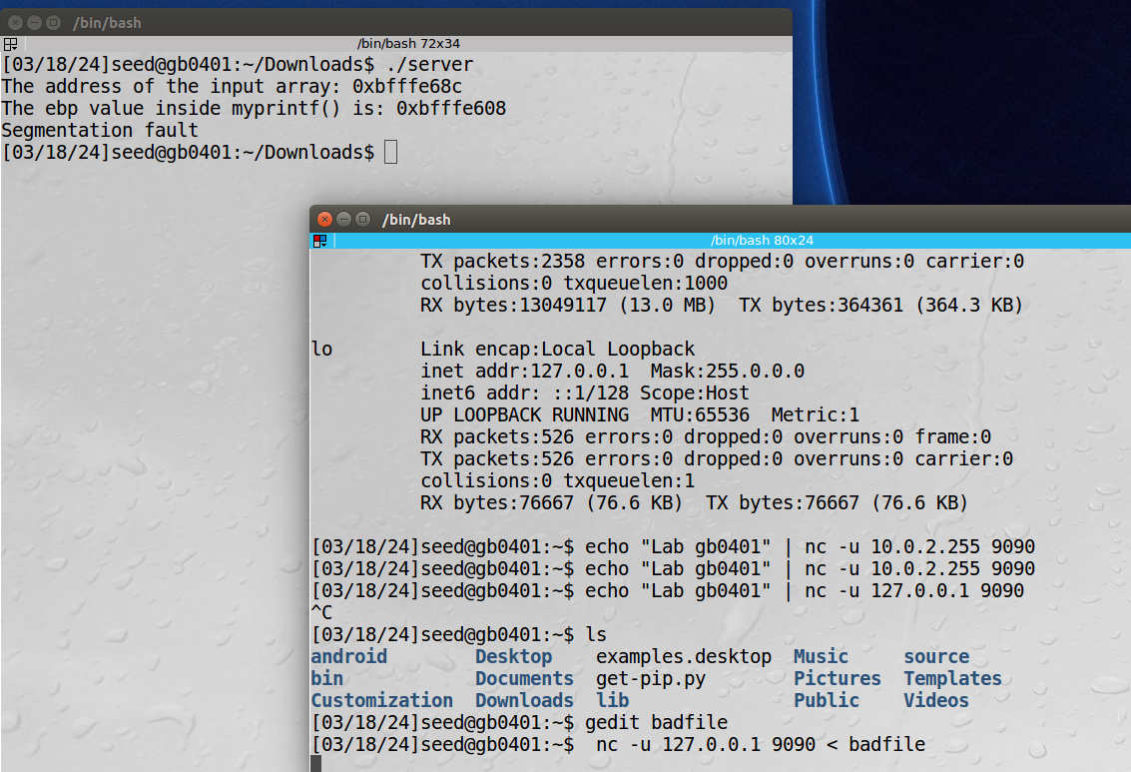

Task 4:

Stack data:

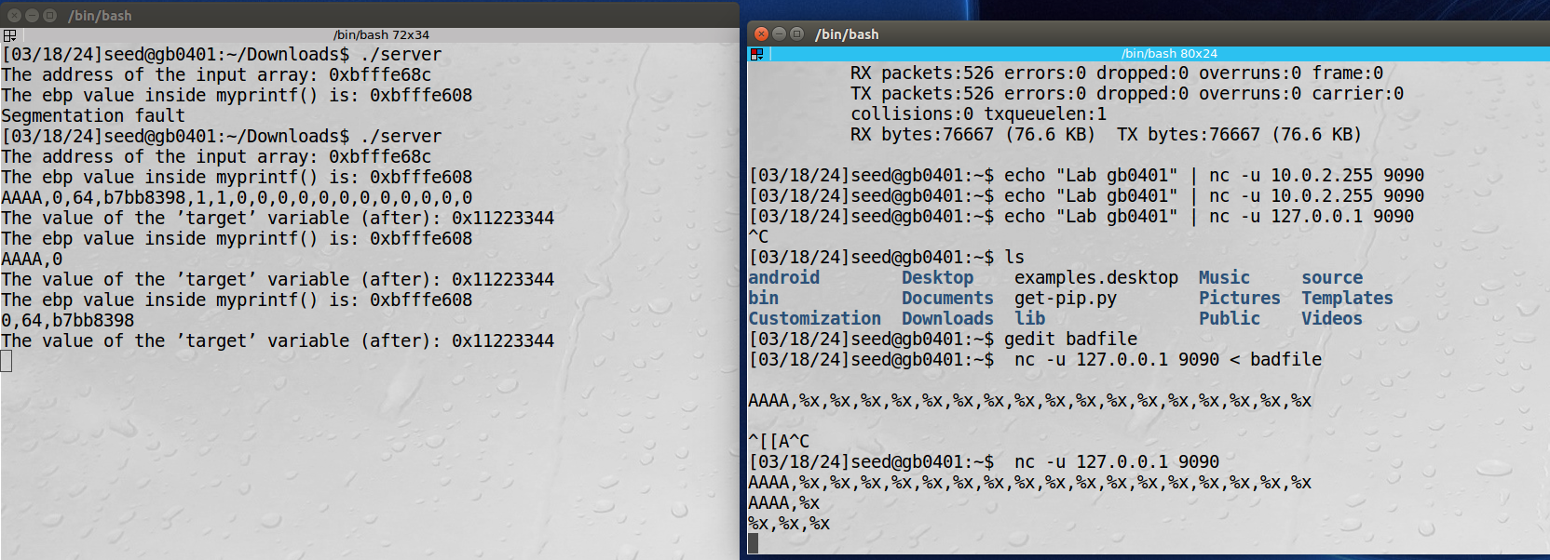

Heap data